 **Maths/ Holiday home works**

**Name : _________________**

**Date : _________________**

**Date : _________________**

**Grade 3:**

1. Learn tables 2-10.

### Activity: Use chart paper or A4 sheet to **draw a multiplication flower**. Use the following image as a guide.

### Start this activity by drawing the centre of the flower, in which write a number between 2 to 10. Then draw 10 petals around the centre, with each petal containing the numbers 1 to 10. The last step is to draw another set of 10 petals which contain the value obtained by multiplication of center number by each petal in the inner circle.

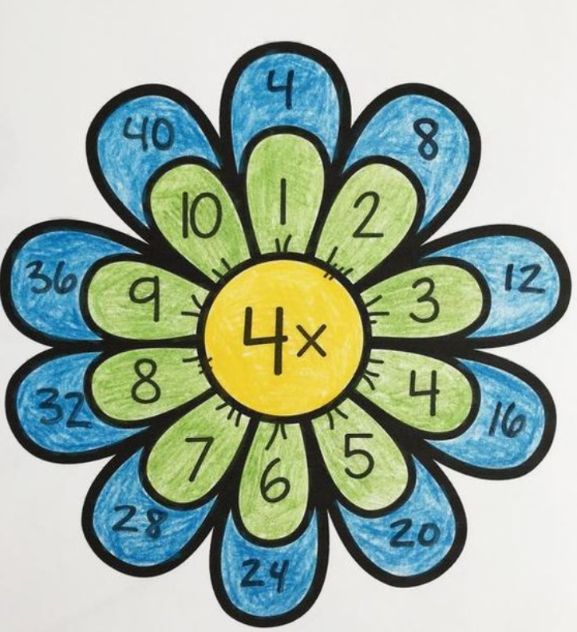

**Grade 4:**

### Activity: Use chart paper or A4 sheet to **make a poster of fraction**. Students can choose any topic from fractions. Use the following image as a guide.

### 

1. Use chart paper or A4 sheet to **make an Area Robot**. Use the following image as a guide.

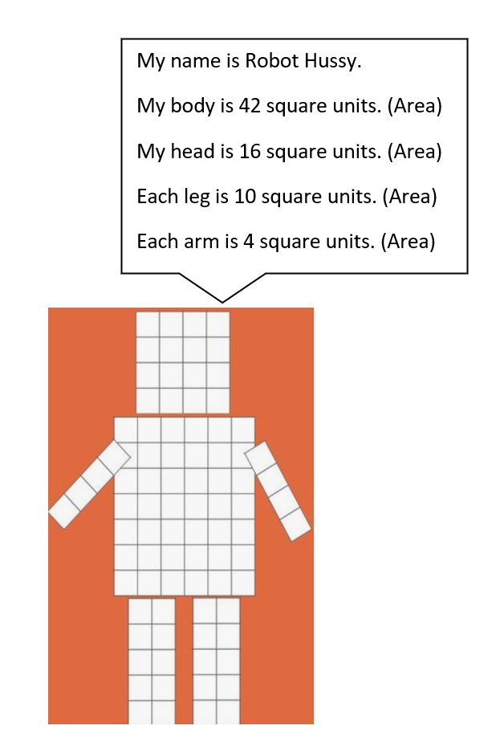

**Grade 5:**

1. Use chart paper or A4 sheet to **make decimal chart**. Use the following image as a guide.

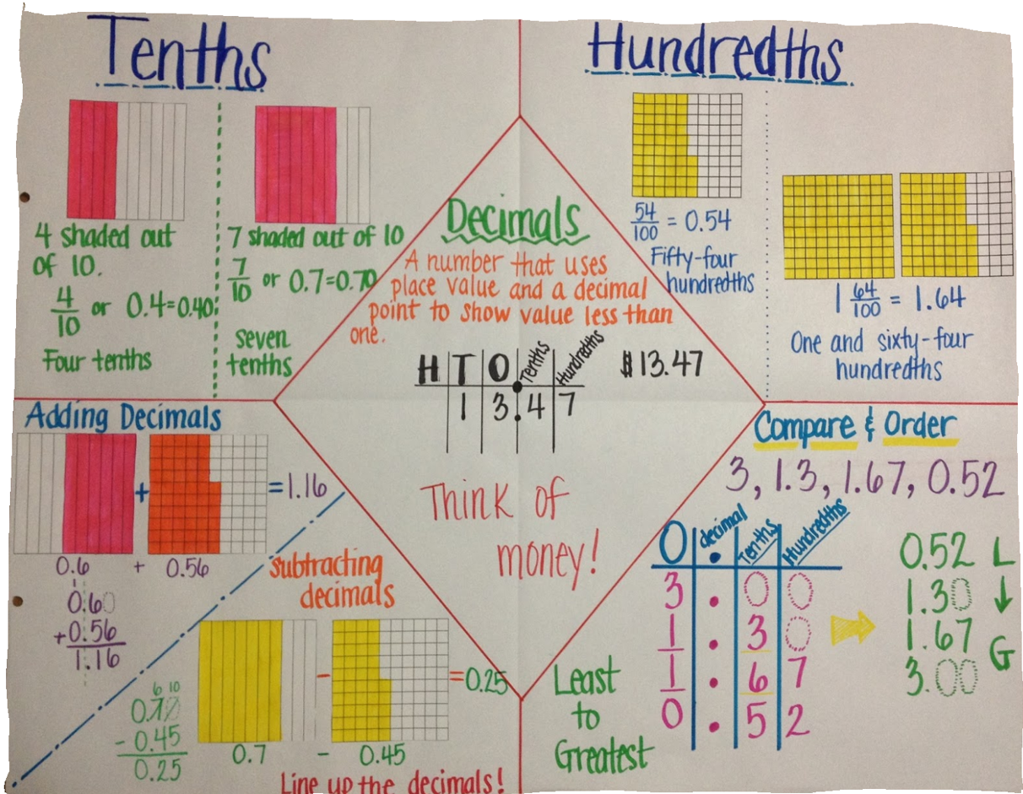

1. Use chart paper or A4 sheet to **make different angles**.

Use a protractor to form and measure some angles of their own and then paste any colourful threads or match sticks over it.

Use the following image as a guide.

